

**CYBER-PHYSICAL SYSTEMS**

**AND IOT SECURITY**

**2024/2025**

**Prof. Alessandro Brighente**

Written by Michael Amista’

**Index of contents**

**1. Course program** 3

**2. Introduction** 4

**3. CAN bus** 7

3.1 Data transmission 9

3.2 CAN bus access and attacks 12

3.2.1 The BUS-OFF attack 13

3.2.2 WeepingCAN attack 15

**4. Keyless Car Security** 18

4.1 Replay attack 19

4.2 Rolling Codes 21

4.3 RollJam/RollBack attack 24

4.4 AUT64 26

**5. Autonomous Vehicles** 29

5.1 Control systems 30

5.1.1 Types of controllers 30

5.1.2 Adaptive Cruise Control (ACC) 32

5.1.3 Cooperative Adaptive Cruise Control (CACC) 33

**6. Drones Security and Privacy** 40

6.1 Safe Hijacking 47

**7. Industrial Systems Security** 54

**8. Attacks and Detection in ICS** 73

8.1 Honeypot 73

8.2 Stuxnet 73

**9. IoT Security and Privacy** 74

9.1 IoT Authentication 74

9.2 Remote Attestation 74

# **1. Course program**

**Fundamentals**

• What is a Cyber-Physical System

• Security Requirements in CPS

**Automotive Security**

• The CAN bus protocol

• Error handling in CAN bus and bus-off attack

• Network attacks on CAN bus

• Keyless cars security and attacks to distance bounding protocols

**Autonomous Driving**

• Introduction to controllers

• Levels of automation and modes of operation

• Attacks on controllers and countermeasures

**Hardware Security**

• Execution flow of modern processors

• Evict+Time, Prime+Probe, Flush+Reload

• Spectre and Meltdown attacks

• Side channel attacks

**Drones**

• Drone components and basic functioning

• Protocols for drone location and fail-safe procedures

• Drone detection systems

**Industrial Control Systems**

• Industrial Control Network Protocols

• PLC and their functioning

• Attacks and countermeasures to industrial control systems

**Internet of Things**

• Network protocols for the internet of things

• Remote attestation

• Intrusion and anomaly detection

# **2. Introduction**

**Cyber-Physical Systems** (**CPSs**) are characterized by the deep complex intertwining among:

• the world of **Operational Technology**, or **OT** [*physical / mechanic operations*];

• the world of **Information Technology**, or **IT** [*communication operations*].

In CPSs there are devices that create and send information *[IT devices]* (for instance, with the CAN bus) and some devices that received the information and do physical operations *[OT devices]* (example: steering the wheel).

Some examples of CPSs are smart grid, smart cars, industrial control systems, e-Health devices.

**Traditional IT Systems**  VS **Cyber-Physical Systems**

 

In this scenario we still have the IT structure but we also have the **ot devices** and some monitoring infrastructure to control their flow (*example*: car without keys 🡪 the monitoring infrastructure needs to check if the car is really closed when we are not near it).

But **adding new devices to the standard IT system, means that the number of breakpoints increase 🡪 more possible attacks**. If we don't have security manager, we couldn't know if all devices are working correctly.

A **security system**: capability of a system to stand the possible security attacks. More layers that manage the security of the systems 🡪 just one is not enough 🡪 assume we have different controllers for all the devices, if one falls the entire system don't fall.

In this scenario we have devices connected to the network. In this type of system, the possible attacks are limited with the communication parts or with the device connected.

If I want to get the information generated with IT Systems I must access to the device or to the active communication.

According to the literature on Cybersecurity, **CIA paradigm** is reversed:



**Top 🡪 down priority**

In our case the most important problem is the **availability of the system**. If nothing is responding I cannot control if all devices are working correctly.



***Confidentiality***: Only the confidential parts of the system should have access to the information. If we are storing customers data, we don't want others to access to this information.

***Integrity***: the detected information should not be manipulated by others --> example: man in the middle.

***Availability***: we want the usability of the system when it's requested.

**Examples of CPSs**:

In the car we have some different devices (battery, breaks, small computer, ecc.) and these devices are all connected to the CAN bus (Controller Area Network) that permit to connect different electronic devices. **But each CAN bus represent a possible point to attack**.

Another important device/possible breakpoint is the antenna that connect the car to the outside 🡪 the car delivers and receive information.

**Vehicles platoon**

Benefits of organizing vehicles in platoons: Fuel Efficiency; Road Capacity; Road Safety; “Greener”.

A vehicle can also communicate with another one. For example: communicate to the platoon that the initial vehicle is breaking so the other ones can break.

**Industrial Systems**

- have dedicated networks and components;

- Operational technology + information technology;

- Dedicated computing systems.

# **3. CAN bus**

What is there in a Car? A lot of different devices:



Modern vehicles contain a large number of **Electronic Control Units** (**ECUs**). ECUs **are embedded systems that control one or more (sub)system in a car or other vehicles**.

*Examples*: engine control module, powertrain control module, transmission control module, suspension control module, ...

**ECUs are nodes in a rather complex in-vehicle network, where they should communicate one another to report many different types of information**.

**Controller Area Network** (**CAN**) **is an in-vehicle network bus-based standard** developed in 1986 by Bosch. It allows in-vehicle components (ECUs) to communicate one another.

It has **broad application in automotive systems**, including power train, suspension, and braking.

In 2003, it became a standard series with ISO 11898.

The Society of Automotive Engineers (SAE) standardized CAN bus communications to have asynchronous data rate up to 1 Mbps at a 40 m distance. Maximal cable lengths should be between 500 m (125 kbit/s) and 40 m (1 Mbit/s).

Why CAN bus:

* **Robustness**: ideal for safety applications thanks to its durability and reliability (bit stuffing, bit monitoring, frame check, ack and CRC checks).
* **Low cost**: objective is to reduce errors, weight, wiring and costs.
* **Flexibility**: it is a message-based protocol, so nodes can be added or removed without updating the system.
* **Efficiency**: messages with high priority are clearly marked and have prioritized access to the bus.

To achieve reliability, it is important to prevent message collision such that no data gets lost. Thanks to the shared bus and the message handling system, CAN allows for a reduced number of wires to achieve reliability.

**CAN BUS ARCHITECTURE**



**ECU ARCHITECTURE**:

1) **MICROCONTROLLER**: The host processor (also called *microcontroller*) decides what the received messages mean and what messages it wants to transmit. Sensors, actuators and control devices can be connected to the host processor.

2) **CAN CONTROLLER**:

- **Receiving**: the CAN controller stores the received serial bits from the bus until an entire message is available, which can then be fetched by the host processor (usually by the CAN controller triggering an interrupt).

- **Sending**: the host processor sends the transmit message(s) to a CAN controller, which transmits the bits serially onto the bus when the bus is free.

3) **CAN TRANSCEIVER**:

- **Receiving**: it converts the data stream from CAN bus levels to levels that the CAN controller uses. It usually has protective circuitry to protect the CAN controller.

- **Transmitting**: it converts the data stream from the CAN controller to CAN bus levels.

## **3.1 Data transmission**

CAN bus uses **differential wired-AND signal**. It uses two signals, CAN high (CAN-H) and CAN low (CAN-L). They are either driven to a *dominant state* with CAN-H > CAN-L. Or driven to a *recessive state*, with CAN-H < CAN-L.

CAN data transmission uses a **lossless bitwise arbitration method**. This arbitration method requires all nodes on the CAN network to be synchronized to sample every bit on the CAN network at the same time. This is why some call CAN synchronous. Unfortunately, the term synchronous is imprecise since the data is transmitted in an asynchronous format, namely without a clock signal.

The CAN specifications use the terms ***dominant bits*** and ***recessive bits***, where **dominant is a logical 0** (actively driven to a voltage by the transmitter) and **recessive is a logical 1** (passively returned to a voltage by a resistor). The idle state is represented by the recessive level (Logical 1). **If one node transmits a dominant bit and another node transmits a recessive bit then there is a collision and the dominant bit wins**. **This means there is no delay to the higher-priority message, and the node transmitting the lower-priority message automatically attempts to re-transmit six-bit clocks after the end of the dominant message**. **This makes CAN very suitable as a real-time prioritized communications system**.

By using this process, any node that transmits a logical 1, when another node transmits a logical 0, loses the arbitration and drops out. A node that loses arbitration re-queues its message for later transmission and the CAN frame bit-stream continues without error until only one node is left transmitting. This means that the node that transmits the first 1 loses arbitration. Since the 11 (or 29 for CAN 2.0B) bit identifier is transmitted by all nodes at the start of the CAN frame, the node with **the lowest identifier transmits more zeros at the start of the frame, and that is the node that wins the arbitration or has the highest priority**.

**CAN FRAMES**

The standard CAN frame is composed by 8 message fields. CAN 2.0A and 2.0B differ in the length of the ID field (11 vs 29 id bits).



* **Start of Frame (SoF)**: dominant 0 to tell the other a node wants to talk.
* **ID**: frame identifier. *The lower the ID, the higher the priority*. **It is not an identifier of the sender**.
* **Remote Transmission Request (RTR)**: indicates whether a node sends data or requests data from another node.
* **Control**: contains the Identifier Extension Bit (IEB) which is dominant 0 for 11 bits. It also contains the 4 bit Data Length Code (DLC) that specifies the length of the data bytes to be transmitted (0 to 8 bytes).
* **Data**: payload in common network terminology. CAN signals that can be extracted and decoded for information.
* **CRC**: check for data integrity.
* **ACK**: indicates whether a node has acknowledged and received data correctly.
* **End of Frame (EoF)**: end of the CAN frame.

**VALIDITY OF THE CAN FRAME**

CAN frames need to satisfy certain conditions to be valid. If a node detects its transmission of an erroneous message, it takes actions accordingly. This is the ***CAN bus error handling***, and **each node has its own error counter and state**. The state is in the set {**active**, **passive**, **bus off**} depending on the counter value.

Counters are **Transmit Error Counter (TEC)** and **Receive Error Counter (REC)** for each node:

* TEC = TEC+ 8 if an error occurs during transmission
* REC = REC + 1 if an error in the reception

TEC increases faster than REC because there’s a high probability that the node that transmit the message caused the error, so it is its fault.

**Success decreases the counter by one in both cases**. Nodes start at the error active frame.

* When TEC or REC is greater than 127 and less than 255, a Passive Error frame will be transmitted on the bus.
* When TEC and REC is less than 127, an Active Error frame will be transmitted on the bus.
* When TEC is greater than 255, then the node enters into Bus Off state, where no frames will be transmitted.

There are two types of error flags:

* **Active Error Flag**: six dominant bits – Transmitted by a node, that is in error state error active, detecting an error on the network.
* **Passive Error Flag**: six recessive bits – Transmitted by a node, that is in error state error passive, detecting an active error frame on the network.
* **These errors are transmitted to report the other nodes that the message transmitted on the bus contains an error**.
* Note: the error transmission violates the bit stuffing rule but with this method when a node receive 6 consecutive 0/1 bits it can recognize that is an error message because the bit stuffing rule does not permit 6 consecutive bits of the same polarity.



When an ECU transitions to the bus off mode it means that something serious is happening. To prevent accidents but still allow the driver to reach a safe place, the ECU in bus off usually runs with predefined parameters and reduced functionality.

In CAN bus transmissions we can have no less than five types of errors **checked by CAN controller**:

1. ***Bit error***: occurs when an ECU, after comparing its transmitted bits with those on the CAN bus detects a mismatch (does not hold in arbitration mode).

2***. Stuff error***: after transmitting five consecutive same polarity-bits, the ECU sends an opposite bit to maintain soft synchronization. An error occurs if stuffing does not happen.

3. ***CRC error***: computed one different from the received one.

4. ***Form error***: if a fixed-form bit field (e.g. EoF) has a bit error the ECU raises a form error.

5. ***ACK error***: when a node receives a frame it responds with a dominant bit in the ACK frame. If none respond, then ACK error.

**BUS ARBITRATION**

It refers to the process by which nodes get a share of the bus resources to transmit. **CAN arbitration protocol is both priority-based and non-preemptive**.

Non-preemptive: a message cannot be preempted by a higher priority one if this was queued after transmission began.

**Time is divided into slots, each with a length sufficient for a message to go back and forth in the whole bus**. A node wishing to transmit checks whether the channel is idle.

If idle, it waits the next slot and start a contention phase by transmitting a SoF bit.

All other nodes wishing to transmit send their ID. The CAN controller compares its output with the actual bus level at the end of each bit cycle.

S1 immediately loses, it begins with a recessive bit. Proceed with S2 and S3 bit comparison and S3 wins.

After the node that wins the competition terminates its transmission with an EoF, there should be new transmissions. The CAN bus uses a 3 bit inter-frame symbols to separate packets. After this, the bus becomes idle again and arbitration shall commence again.

## **3.2 CAN bus access and attacks**

To access CAN bus you need to connect to the On Board Diagnostic (OBD) port. Basically all cars nowadays use the OBD-II standard port. It is usually located near the driver’s or passenger’s seat. To talk with the CAN bus you need a converter, such as in the figure. This converts CAN bus data to something readable via a USB port.

The bus-off attacks is a denial of service attack that exploits how ECUs access the bus.

The error handling mechanism of CAN bus forces ECUs that measure a certain number of errors to go bus-off 🡺 **the attacker exploits this feature of CAN bus to iteratively isolate ECUs**.

Injecting attack messages, the adversary coerces the TEC of an uncompromised/healthy victim ECU to continuously increase. Eventually, the attacker forces the error confinement to force the victim

or even the entire network to shutdown.

### **3.2.1 The BUS-OFF attack**

Suppose that a victim V periodically sends a message M. The attacker (must know when V transmit) can hence deliver a successful bus-off attack by (all conditions must be fulfilled):

- Using the same ID

- **Transmitting at the same time as M** (the tricky part of the attack)

- Having at least a bit that is dominant in the attack message while being recessive in M



**Phase 1: Victim in Error-Active**

* Both adversary and victim start in error-active mode, and the attacker targets one of the victim’s periodical messages.
* The attacker sends the malicious message and the victim’s TEC increases.
* The attacker’s TEC also increases, due to the stuff or bit errors triggered at the adversary node. *Whenever there’s an error due to failed transmission of a packet the CAN controller tries to retransmit same packet on can bus* 🡪 *both victim and attacker TEC increases*.
* Both nodes automatically retransmit the failed message.
* **Thanks to the automatic retransmission, the attacker brings the victim to *error-passive* by sending a single message**.



Note an important difference here: the victim has an error due to failed transmission of packet while attacker has an error due to the victim’s active error flag. So, the victim and the attacker TEC increases in **different times** and for different reasons 🡪 fundamental for the success of the attack.

**Phase 1 to 2**

* After 16 retransmissions, both victim’s and attacker’s TEC=128 → error-passive.
* As a consequence, the victim attempts the delivery of a passive error flag with 6 recessive bits.
* **The passive error transmitted by the victim cannot override what is in the CAN bus, so the attacker successfully transmits its message and return to error active** (attacker’s TEC = TEC -1).
* **Due to the successful transmission, the adversary does not go to error-passive.**



**Phase 2: Victim Error-Passive**

* Once the scheduled interval of the target message is elapsed, V retransmits M again.
* At the same time, the adversary reinjects malicious M.
* Since the victim is in error-passive, the attacker’s TEC decreases by 1, whereas the victim’s. increases by 7 (+8 -1) thus maintaining the error-passive.
* The attacker iterates until the victim’s TEC > 255, i.e., bus.



**Important note**: remember that CAN ID do not contain actual information on the transmitter. The ID contains information that define the time interval and priority of messages. The attacker should hit low-value IDs (dominant) to disconnect possibly safety-critical ECUs.

**DIFFICULTIES OF THE BUS-OFF ATTACK**

**ECUs cannot acquire all the IDs of all received messages**. Only of those that pass through its message filter. We can distinguish hence between ***received*** message (that we only see and read the content) and ***accepted*** message (messages that contains some information related of what we have to do, some physical operation for instance).

The attacker can only read the ID from accepted messages, and he can create only messages with the same ID depends on the filter of the victim ECU 🡪 if there is no filter then done, but filters can be remotely manipulated.

One problem of the bus-off attack is that we need **precise synchronization**, so if we don’t transmit the malicious packet as soon as the victim is transmitting its packet then the attack is not going to work.

We can achieve the synchronization without take care about the exact time of the victim’s transmission: **all messages and priorities are periodic and we can exploit this to infer when a certain message is going to be transmitted** (preceded message). Usually when a packet’s transmission in the CAN bus ends we wait for 3 bit-time before starting the transmission.

The bus-off attack is easily detectable by a good intrusion detection system (the malicious message is always the same). ***WeepingCAN*** is a variation of the original bus-off attack, stealthier than the original one and more difficult to identify.

Differences:

- The attacker disables the transmission of the attack message with the same ID as the victim.

- The attacker causes recessive bit errors.

- The attacker does not fabricate preceded messages.

- The attacker randomizes bit errors.

### **3.2.2 WeepingCAN attack**

The attack message has the victim’s ID, bit-time, and prefix bits until a random position where the **victim is dominant but the attacker is recessive**. As for the original bus-off, both attacker and victim have TEC = 0 at the beginning. **The goal of weepingCAN is to avoid exhibiting temporal differences due to the error state transition**.

**Attack Cycle**:

* The attacker synchronized with the victim using the same approach of the original bus-off.
* The attacker however disables its retransmission of the packet with error 🡪 if we see a lot of retransmissions maybe there’s something wrong 🡪 DETECTABLE 🡪 so we disable them.
* The attacker injects the attack message.
* The attacker’s CAN controller sends an error-active flag due to the bit error in the attacker’s packet, which increases both attacker’s and victim’s TEC by 8.
* The victim retransmits successfully the original packet (because attacker cannot retransmit) and TEC=TEC-1.
* Victim and attacker decrease TEC for other transmissions.

Disabling retransmission allows to remove an easily detectable feature, i.e., the consecutive retransmissions of the same packet. The attack is now composed by an active error + successful retransmission. Two ways to avoid retransmissions:

- Disable automatic retransmission for all messages (via control register).

- Abort transmission on transmit error (via interrupt).

**Recessive Injection**:

* The attacker injects a recessive bit when the victim “contains” a dominant bit.
* Both attacker and victim increase TEC by 8, however only the victim retransmits (TEC = TEC - 1).
* The attacker must identify additional messages it can transmit to keep its TEC lower than that of the victim.
* The attacker, to don’t pass to error passive state, needs to transmit at least 1 more message than the victim for each attack packet that it transmits.

**Basic attack strategy**:

* Suppose that the attacker and victim both have a single message they can send.
* Suppose A sends its packet with one fifth the period of V.
* Thus, for every attack message, A transmits 5 messages while V transmits 1 → TECA=3, TECV=7.
* V can be forced to error passive with 19 attack messages.
* A needs to be careful not to reach error passive before V goes bus-off!
* A can decide to skip some injections if its TEC is increasing faster than the V’s TEC. Meanwhile it can transmit some successful messages to decrease its TEC.

**Randomized bit position**:

The second feature making bus-off identifiable is the presence of successive messages over the passive error flags of the victim. Furthermore, the attacker may always use the same packet for the attack. Therefore, it might be good for the attacker to have the possibility to randomize packets.

In particular, to randomize the position of the error bit. The DLC of most messages is a fixed constant that can be discovered by offline analysis of a CAN trace. The number of dominant bits in DLCs vary between 1 and 3, so the entropy is low. A clever attacker may inject recessive error in the data field.

The data field often encodes a number that does not change quickly because of physical constraints or an event identifier that comes from a limited set of event. If A can identify a deterministic pattern → inject error in the data.

# **4. Keyless Car Security**

**PHYSICAL KEYS**

At the beginning, there were ignition systems. Ignition switch is the first step to get a car to start. Turning the key sends a signal. This signal starts the ignition system and ignites the fuel vapor.

This system has a critical flaw: **you can generate this signal in many ways if you have physical access to the car**.

The first solution involving a cyber-component to enforce security is the **immobilizer**.

The first generation of immobilizers used a small chip embedded into the head of the car key.

Purpose: when the driver inserts the key into the cylinder, **the chip emits a code/serial number that can be received by the antenna inside the cylinder**. If the code matches the one the car expects, then ignition starts.



**PROBLEM**: the immobilizer always transmits the same code. **An attacker** with an eavesdropping equipment **can easily record the code and later replay it when stealing the car**.

Immobilizers of cars such as Ford, Toyota, and Nissan were based on **Digital Signature Transponders** (**DSTs**). The DST is a tiny RFID chip that, among the others, is enabled with a cypher F() and a 40-bit secret key. The DST and the car both share a copy of the private key K.

IDEA: The car and the DST share secrets, and we can use the key K to decrypt this information.

Initially the car sends a 40-bit challenge to the key. The DST encrypts the challenge sent by the car thanks to K and sent it back to the car 🡪 now the car knows K (symmetric key) and it uses K to decrypt the information received by DST (the challenge) and if this information matches, we’ve done.

**PROBLEM**: **the challenge generated by the car is not temporary, so we cannot know if the challenge has been generated now or in the past**. **An attacker can capture this value and replay it**.

T**here is another a huge problem with the key length**, i.e., **40 bits**. An attacker might send a challenge and record a response from a car and try all the 1.1 trillion possible key combinations to infer the private keys. Huge number but requires few hours on a FPGA.



Now we have two secrets instead one 🡪 challenge is encrypted twice (with K and MAK). We are creating the challenge X and encrypt with K, then I re-encrypt all with MAK and I send it to the key.

## **4.1 Replay attack**

An evolution of keys is **Passive Keyless Entry Systems** (**PKESs**). It does not require interaction with the user 🡪 there isn’t any button to be pressed 🡪 “hand free experience” 🡪 evolution of RKE. **The car not only checks for the presence of a legitimate code but checks also where the key is**. It uses a low-frequency RFID channel to check if the key is in remote distance (up to 100 m), outside the car (1-2 m from the door handle), or inside the car. Only in the last case the engine starts.

**A different threat model envisions having no direct access to the car’s key**. Still, keys use wireless communications to talk with the car and execute a challenge response algorithm.

🡺 How do you steal a car in a minute exploiting this technology and why would this work?



We define as a **relay attack** a **special type of man in the middle attack, where a non-legitimate device establishes a communication between two non-proximal legitimate devices**.

When relaying signals, **we need to care only about the physical layer**. We do not need to interpret the signal, modify it, infer keys, … **We just need to demodulate the signal, amplify it if needed, transmit it as digital information using RF, and modulate it near the victim tag** (we take care about the radio waves, but we don’t want to change their shape we just want to increase their amplitude if we need more power in the signal).

Note: this type of attack adds some delay to communication, so we must be sure that the introduced delay is within the range accepted by the application under attack.

**IMPLEMENTATION OVER CABLE**



Two loop antennas connected via a cable that relays the low frequency signal between them. One antenna communicates with the car and the other one with the key. **The car and the key thinks they are closed so the generated command are accepted.**

**IMPLEMENTATION OVER THE AIR**

Cables may bring suspicions so, let’s just remove them. The relay system is now composed by two parts, an emitter and a receiver:

* The **emitter** captures the low freq. signal and upconverts it to 2.5 GHz, amplifies it, and transmits it over the air.
* The **receiver** downconverts the signal back to low freq., it amplifies it agains, and sends it to the loop antenna.

Note: in this implementation we need to take more care about the wireless communication and the lost of information.



**Possible countermeasures**:

* Distance bounding denotes a class of protocols where the prover measures an upper bound on its distance to another entity.
* We implement RF distance bounding to verify the mutual proximity of the car and the key.
* The distance bound is obtained from a rapid exchange of messages.
* The verifier sends a challenge to the prover.
* Upon reception of the response, the verifier measures the communication round trip time to obtain an estimate of the distance.

## **4.2 Rolling Codes**

Remote Keyless Entry (RKE) relies on unidirectional data transmission from the remote control (in the car key) to the vehicle. **The key is hence active, and upon pressing a button transmits signals** in one of the bands 315 MHz, 433 MHz, or 868 MHz (depending on the country).

RKE systems enable the user to comfortably lock and unlock the vehicle from a distance and can be used to switch on and off the anti-theft alarm when present.

The first generation of RKE used no cryptography, solely relied on a fix-code signal. However, this makes replay attacks super easy. The next generation of RKE is named after **rolling code systems**.

**Rolling codes use cryptography and a counter value that is increased at every button press**. They use a conjunction of the counter and other signals as input to the cypher, and the car checks this information to assess the validity of the signal.

Then follows the type of data that we sent with RKEs systems.



* **Preamble**: is fixed and it’s used by the car to detect the presence of messages.
* **Start**: used to start a conversation/information transfer.
* **Payload**: in order to avoid replay attacks we need to encrypt its content. In the payload there is a: **unique identifier** (id of the key), **rolling counter value**, **pressed button**. There’s also the time information about when the key generated the packet.
* **Checksum**.

**🡺 Implicit authentication**: the entire payload is symmetrically encrypted, and the receiver checks the UID and if the counter is in its validity window (if there is a correspondence between the car’s and key’s counter).

**🡺 Explicit authentication**: the sender computes some sort of message authentication code over the data payload and appends it to the packet.

**One of the many implementations**:



The grey part is the encrypted part. The payload is encrypted using a proprietary block cipher. We assume that such a **cypher is the AUT64** (as found in many cars from the VolksWagen group).

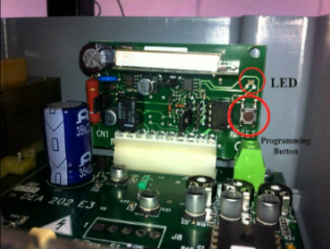Both the car and remote are synchronized to an initial number (e.g., PRNG seed) → pairing a remote. It usually relies on some configuration, such as pressing a button or a master key.

Once the remote and the car are synchronized, they use an algorithm to choose an initial number **x** and transform it to the next number in the sequence (**x+1**) 🡪 not necessarily the following number.

**The following key press will take the result of the previous keypress as the input**. If a single remote press is intercepted there is no way to determine the next code expected by the receiver (due to encryption).

Note: the difference between the button of the key and the car is that **when you press the button of the key the key’s counter always increases but the car’s counter increases just when it receives a valid message**.

If we start the counter from 0 and we increase the next counter value +1 is easy for the attacker (replay attack) to predict the next number related to pressing the key button BUT choosing a random initial number and encrypting the counter is not possible for the attacker to predict the value.

Devices not only store the next code that needs to be transmitted, but a significant number of them (e.g., 255). **This is fundamental to have the process working even if in case of erroneous keypresses that increase the counter only on the key side** 🡪 we can recover the right value.

**As soon as a button keypress that is valid is received, the list is updated to be x iterations from that keypress = [1..255] 🡪 [2..256]**. However, **if the number of keypresses is too large, there is no way to catch up on sync**.

There are few well-known manufacturers providing rolling code based RKE. Microchip Technology provides Classic, Advances, and Ultimate KeeLoq with publicly available documentation and data sheets. Companies like NXP, Omron, and TI provide proprietary solutions.

Let’s take a deeper look at KeeLoq (as it is open source), provided that the idea behind rolling codes is always the same.

**KEELOQ IMPLEMENTATION**

Uniqueness of messages in key fob transmission is achieved by incrementing a 16 bytes counter in the key fob (and vehicle upon reception). A button press is valid if counters at each side are in sync.

* **If the difference between the key and car counter is small (i.e., < 16), counter synchronization takes place immediately at the first button press without additional steps**. Sync means that the receiver unit in the vehicle invalidates all non-received codes before the one present in the last keyfob signal.
* **If the difference is higher than 16 and lower than 215, the receiver temporarily stores the counter and waits for a subsequent transmission** (same button has to be pressed once more). This situation happens when we have pressed the same button more time, so we don’t have exactly the difference of 16 bytes but 16*…*16 🡪 n times. **If the subsequent transmission has counter previous +1 (the second transmission), the receiver resynchronizes on the last transmission received**.
* If any of the above fails, the key fob signal received by the vehicle is discarded.

## **4.3 RollJam/RollBack attack**

As an attacker, **we would like the receiver not to be able to receive any of the radio transmissions from the remote**. To achieve this, **we can jam the communication between the key and the car**.

This is a **technique used by thieves to have drivers not to close their cars in the parking lot** 🡪 when the owner of the car press the key button to close his car there’s a jamming that blocks the signal and the car doesn’t receive the signal from the key, so the owner goes away thinking he closes the car and the thief steals the car.

Notice that we can use a transmitter on a similar frequency, as receivers have large windows for detecting signals (to account for temperature changes and flat batteries).

**Remote jamming works, but the person walking away from the car may notice that it did not lock** (no noise).

We want to develop a technique that is indistinguishable from the standard interaction between car and owner. We integrate jamming and replay attack in the RollJam attack. **We want to jam the signal, capture it, and somehow reply it as a legitimate communication between key and car**.



While the signal is jammed, we can use the same window to capture the first legitimate message that the key sent to the car. This is possible because the jamming is not in the exact same frequency of the signal. **Thief can store the signal and use it later 🡪 the car doesn’t receive anything (its counter doesn’t increase), so the captured signal (current+1) is still valid**.

When someone cannot get a remote to work, the instinctive reaction is to press the remote again. As soon as this happens, we can get a second (successive) instance of a legitimate transmission.

**We can replay the first signal to lock the car so the owner goes away and then we can use the second captured signal to unlock the car**.

**This attack works only in key fob with lock/unlock functionalities in the same button**.

**PROBLEMS**

**🡪 Many modern cars use different frequencies (different buttons) for lock and unlock**.

🡪 If the attacker only monitors the frequency of the unlock button, then they will only be able to unlock the car.

🡪 It requires the legitimate owner to send a legitimate lock, before being able to perform the unlock, given that lock and unlock use the same rolling code.

Solutions: permanently jam the lock frequency such that the user will need to manually lock the car.

Again, RollJam requires the jammer to be always there. Although rolling codes have been designed to prevent replay attacks, they are still chances that replay might work.

We said that there may be some synchronization issues between key and car for which resynchronization is needed 🡺 let’s exploit this mechanism to evade the security provided by

rolling codes.



1. The attacker places the RollBack-device near the target car.
2. When the victims comes back to their car, they will try to unlock it via the keyfob sending *SendV(Siunlock)*
3. RollBack-device:

* Capture the signal
* Jam the frequency band to prevent reception

1. The victim assumes lousy reception and presses the same button again, sending *SendV(Si+1unlock)*
2. The RollBack-device captures the signal, but lets the car receive it → the victim unlocks and drives away (no doubts).

**By design, the two codes captured by the attacker are no longer valid**. The victim can lock and unlock their car at will.

However, **we have also seen that resync requires two consecutive packets. This means that the attacker can replay the two previously captured packets at any time and get access to the car (????)**.

## **4.4 AUT64**



Doing the math, the effective key size of AUT64 is 91.55 bit. Finding the key via exhaustive search is not practical. However, the problem is that this RKE system uses a global master key which is independent from the vehicle or remote control. We can use the master key to generate new keys.

This means that **the** **same key is stored in millions of ECUs and RKE remotes, without any key diversification**. The sole means by which the vehicle determines if a rolling code is valid is hence by whitelisting certain UIDs and checking if the counter is within the validity window.



The cipher consists of a 48-bit Linear Feedback Shift Register and a non-linear filter function f.

Each clock cycle, twenty bits of the LFSR are input to f to generate a bit of the keystream.

The LFSR is then shifted one bit to the left, using the feedback polynomial to generate a new bit on the right.





* During the authentication protocol, the internal state of the stream cipher is initialized.
* The internal state consists of the 32-bits UID concatenated with the first 16 bits of the key k.
* The counter ctr is incremented and iv = ctr || btn is XORed with the last 32 bits of the key and shifted into the LFSR.
* For this point, the next 32 bits of the keystream (output by the cipher ks) are sent as a proof of knowledge of the secret k.

**CORRELATION ATTACK ON HITAG2**

The purpose of the attacker is to retrieve the key. It requires a minimum of four rolling codes, but it would be faster and more precise by having more traces.

Rolling codes may have an arbitrary counter value, i.e., non consecutive. However, this is good as it increases correlation. We denote as <UID, ivj, ksj>, j = 0,...,n-1, n>3, n authentication traces.

1. The adversary first guesses a 16-bit window corresponding to LFSR stream bits a32,..,. a47 = k0,...,k15.
2. Together with UID, this gives the adversary a0, …, a47, which is constant over traces.
3. The adversary can hence compute b0 = f(a0, … , a47).
4. The adversary shifts this 16-bit window to the left of the LFSR, until bits a32, .. , a47 are on the very left of the LFSR, i.e., the point where the cipher starts outputting ks.
5. The adversary computes a correlation score for this guess
6. The window determines 8 input bits x0, …, x7 to the filter function f20, while the remaining 12 inputs remain unknown.
7. The correlation is taken as the ratio of those 212 input values x8, …, x19 that produce the correct keystream bit ks0.
8. Shifting the window further to the left, the adversary can perform tests on multiple keystream bits (ks0,..., ks15).
9. The adversary assigns this guess the average score over all traces.
10. So far this scoring computation is independent of the value iv as it happens before iv gets to have any influence on it.
11. The adversary sorts guesses based on their score and stores them in a table, discarding guesses with lowest score if needed.
12. Experiments show that 400, 000 guesses are usually sufficient.
13. For each guess in the table, the adversary goes back to Step (1) and proceeds as before, except that she will now extend the window size by one guessing the next LFSR stream bit (a48, … , a51).
14. The power of this attack comes from using the window on the right of the LFSR to compute the necessary keystream bits to correct the internal state.



# **5. Autonomous Vehicles**

An autonomous vehicle is **a car capable of sensing the surrounding environment and take actions without human intervention**.

These types of vehicles need a lot of sensors, include thermographic cameras, GPS, inertial measurement units, etc. **The sensors’ output is used as input for a controller which creates a model to identify the most appropriate navigation path**.

Note: when we talk about an autonomous vehicle, it doesn’t refer just to cars but also to drones, robots in some factory, etc.

Autonomous vehicles use different types of sensors to *perceive the environment* (for instance to detect obstacles) and *monitor their own physical parameters*:

* Cameras
* LiDAR
* RADAR
* SONAR
* IMU
* GNSS

**Sensor fusion techniques** are used to reduce measurement uncertainties due to noise 🡪 a specific class of algorithms that controls the output from sensors (maybe a sensor doesn’t work well).

**PLANNING PHASE** (the main goal of AV): using the data obtained from the perception system, the vehicle performs behaviour planning. Based on the planned behaviour, **generate an optimal trajectory**. The entire process is called motion planning.

**SAE LEVELS OF AUTOMATION**

The Society of Automotive Engineers (SAE) defined 6 levels of driving automation:

* **Level 0**: no automation, manual control.
* **Level 1**: driver assistance with monitoring functionalities (e.g., cruise control).
* **Level 2**: partial automation with the car taking autonomous actions such as steering and acceleration, but the human can always take back the control.
* L**evel 3**: conditional automation, where the vehicle can perform most of the driving task, but human override is still required.
* **Level 4**: high automation where the vehicle performs all driving tasks under specific circumstances and in geofenced areas. Human override is still an option.
* **Level 5**: full automation with the vehicle performing all driving tasks in all conditions. No human attention or interaction is required.

**There are several limitations and barriers that could impede adoption of AVs**, including: the need for sufficient consumer demand, assurance of data security, protection against cyberattacks, social distrust, and the development of economically viable AV technologies.

## **5.1 Control systems**

**Cruise Control** (CC) is a system that **automatically controls the speed of a motor vehicle**. It is a system that automatically **uses error-sensing negative feedback to correct the throttle of the car and maintain a constant speed**.

CC is a simple implementation of a control system that, in control theory, is called **proportional-integral-derivative (PID) controller**.

**Control Theory** is a field of engineering and applied math that deals with the control of dynamical systems. The objective is to develop a controller, a device that acts on the system to achieve a desired state.

**The controller monitors the process via a *process variable* and compares it with a *reference* or *set point*** (the input given to the controller 🡪 target, in the case of CC = the speed). **The difference between these values is called the error signal**.

*Example of a possible scenario*: if we want to maintain a certain distance from the car above, we communicate the distance reference value to the controller, it computes the error signal and do some operations to minimize the error in order to reach the given distance value.

### **5.1.1 Types of controllers**

**OPEN LOOP (FEEDFORWARD) CONTROLLER**



We provide a reference signal to the controller; it implements a function which computes an output that instruct the system on what it has to do to reach the target. At this point the process computes an output which is the current system value.

For instance, a boiler that needs to heat the water for a given amount of time.

**CLOSED LOOP (FEEDBACK) CONTROLLER**



Compares a value that is given by the process with the reference input. The difference from the previous one is that **the process’ output is returned to the controller to adjust as much as possible the current system value** **in order to reach the reference input**. For instance, a car’s cruise control or a thermostat.

A control system for an autonomous vehicle is broken down in two fundamental components:

* **Longitudinal control** (speed up/slow down + brake): control of the longitudinal motion of the vehicle.
* **Lateral control** (left/right steer): control the lateral dynamics of the vehicles.

**Kinematics is the study of motion of a system disregarding the forces (wind, etc) that govern it**.

Can be employed in situations wherein kinematics relations are able to sufficiently approximate the actual system dynamics. Valid only for systems that do not perform aggressive manoeuvres at lower speeds 🡪 driving slowly and making smooth turns.

We however start from them to make things simpler.

**BICYCLE MODEL**

Model to capture vehicle dynamics under normal driving conditions. Strike a good balance between simplicity and accuracy → widely adopted.

**The idea is to define a vehicle state and see how it evolves over time based on the previous state and current control inputs 🡪 defining its behaviour**. Let the vehicle state q comprise the x,y coordinates of location, heading angle theta, and velocity v:



(complete example on the slide)

**PID CONTROLLER**



It is a control loop mechanism using feedback to apply continuously modulated control.

**It continuously computes an error as the difference between a desired setpoint and a measured process variable. Based on the error value, it applies a correction** **based on** **proportional (P), integral (I), and derivative (D) terms**.

Based on the type of error computed, the **controller applies a correction**:

* **Proportional (P) term**: the proportional term is directly proportional to the current error (the difference between the desired setpoint and the actual process variable).
* **Integral (I) term**: the integral term considers the accumulated error over time.
* **Derivative (D) term**: the derivative term considers the rate of change of the error. It predicts future error based on the rate of error change and applies a corrective action to counteract sudden changes in the process variable.
* Kp, Ki and Kd determine the magnitude of the correction.





### **5.1.2 Adaptive Cruise Control (ACC)**

Adaptive Cruise Control (ACC) is a system that automatically controls the speed of a motor vehicle by integrating sensing capabilities on the vehicle [SAE Level 1].

The vehicle uses a radar/LiDar/laser to compute the distance from a car in the front. This distance is reported to the controller, which acts on the speed to maintain a minimum safety distance.

*Scenario*: assume we have two cars, one in the front (lead) and one in the back. We assume that the one in the back (ego vehicle) has ACC. Ego uses a radar to measure the distance to the lead vehicle. The lead car is supposed to be driving in the same lane. Ego also uses the radar to measure the relative speed between the two cars.



**First mode**: the ego vehicle should drive at a driver’s specified speed as long as it maintains a safe distance with the lead vehicle.

**Second mode**: the space between the two vehicles is controlled (by changing the ego vehicle’s speed) so that the two vehicles do not get closer than a safe distance.

According to real-time measurements, **either working modes can be enabled by the ACC system**.

To determine the operating mode, the ACC applies the following rules:

🡪 If relative distance is >= safe distance, then use speed control (first) mode to track the driver set velocity.

🡪 If relative distance is < than safe distance, then the space control (second) mode is active and keep track of the distance.

We explore two different attack scenarios in which we assume the attacker can compromise in some way the ACC unit 🡪 two scenarios:

1. **The attacker remains dormant** and monitors the measured distance to the front vehicle. At the times this distance is at its lowest (presumably near the minimum safe distance), it creates a spike (a very high signal) in the control signal and makes the vehicle accelerate. This could similarly happen when the front vehicle suddenly brakes and the compromised ACC refuses to reduce the speed.
2. Unlike the first scenario **the attacker does not hide for the attack**. Trivially lowers the ACC’s reference distance. During the times ACC is in mode 2 and tries to maintain the safe distance, it is practically following a false reference. Since this difference is trivial and not noticeable to the driver, this attack remains covert or stealth.

### **5.1.3 Cooperative Adaptive Cruise Control (CACC)**

Cooperative Adaptive Cruise Control (CACC) is **a system that automatically controls the speed of a motor vehicle by integrating sensing capabilities on the vehicle and communication capabilities with other vehicles**. It uses Vehicle-to-Everything (V2X) communication. In addition to what ACC does, **CACC uses the preceding vehicle’s acceleration in a feed-forward loop**. This info passes via the Cooperative Awareness Messages 🡪 we are creating a communication with other vehicles: a vehicle communicates its status to the other ones.



**Perception Phase**:

* Get information from on-board sensors and include them in CAN data.
* The Wireless Safety Unit (WSU) provides i) data transmitted by other CAVs in the CACC system through V2V communications, ii) data collected by GPS with wider area augmentation system differential corrections (e.g., vehicle position assigned in the CACC system).
* Information derived from on-board sensors such as Lidar, odometer and flag signals will also be received and included on the CAN bus data structure.

**Planning Phase**:

* Includes the high-level controller (longitudinal control algorithms).
* The controller is usually connected and instructs the vehicle via the CAN bus.
* Very similar to ACC.

**Actuation Phase**:

* Execute target reference command transmitted from the planning phase.
* Low-level controller converts the target speed commands into throttle and brake actions.

The vehicle dynamics is calculated by the vehicle controller and controller acts only on its vehicle. In particular, we often use longitudinal control, **we write the sum of the forces acting on the vehicle and use them to maintain the same longitudinal speed of the other vehicles in a CACC system** while keeping a fixed longitudinal inter-vehicle distance.

CACC technology allows CAVs to form vehicle platoons with shorter inter-vehicle distances.

**MODEL OF CACC**







**ATTACK STRATEGIES**

An attacker can cause a series of abnormal behaviours in CACC system, in particular referring to the platooning case. The attacker may either be an external actor or an inner vehicle/byzantine node.

1. **Reduced headway attack**: a car ignores the recommended  headway speed that guarantees string stability and follows closer. This attack would likely be implemented by a driver who wants to increase fuel savings by decreasing draft or a driver who manually drives with extremely small headways.
2. **Joining without radar**: a car attempts to become part of a platoon without having the necessary radar, or other distancing equipment. A driver who does not want to buy a new vehicle but retrofits a car with DSRC which, unlike radar, does not require per vehicle tuning. The reaction of the car is uniquely based on the feedforward information which is dangerous in case of communication problems (e.g., congestion). The attacker control strategy is hence .
3. **Mis-report Attack**: The attacker misinforms the vehicle that is following to increase the following car’s headway or to cause a change in the following car’s behaviour. The attacker mounting this attack could either follow the prescribed control law or choose an alternative control law. Assuming the attacker misreporting only its behaviour, then . This is motivated by wanting to increase the following distance of the preceding car.
4. **Collision Induction Attack**: the attacker broadcasts an acceleration profile indicating that they are speeding up which causes the following vehicle to accelerate. The attacker starts to aggressively brake which causes the error between the attacker and following car to quickly increase. Very similar to attacks that could be mounted in the current highway system. If a driver was to jam on their breaks during rush hour while being tailgated, the vehicle would likely be rear ended.

***Summary***



**How do we detect and defend against these attacks?**

We can describe our CACC system with a double integrator model with a lag constant nu for each car:







**MODEL BASED DETECTION**

Every car model the expected behaviour of the vehicle directly in front of them. Vehicles then compare the calculated expected behaviour with the observed behaviour. The car is then able to detect both malicious and benign abnormalities. Once abnormal behaviour is detected, the car switches from operating in a cooperative platoon framework to a radar only based adaptive cruise control framework where it is safe even if the preceding car is mounting an attack.









The modeling technique is based on double integrator and can be made complicate at wish. Considering tradeoffs in accuracy, calculation cost, and time for calculation. Improvements that could be considered in the modeling include capturing non-linear behavior of the vehicles drivetrain and using terrain mapping to predict variation.

**THRESHOLDING**

Once we have the prediction model, we can predict whether the error is acceptable or not.

We indicate the measured values as , also we assume we can compute acceleration and velocity. However, we cannot measure the error since we do not have a line of sight with cars further than a single hop.



**DIFFERENT METHODOLOGY**

Model predictive control can be implemented in multiple ways. In the previous example, each vehicle implements the model of the preceding vehicle. However, we can model more complex systems. For instance, it could be possible for vehicle i to simulate the entire platoon up to vehicle i-1.

# **6. Drones Security and Privacy**

**Unmanned Aerial Vehicles** (UAVs) are flying devices without any crew or pilot on board. They come in different shapes and size, and can reach different altitudes.

**OPERATING MODE**

* UAVs may be operated by pilots located on the ground
* Remotely Piloted Aircraft Systems (RPAS)
* Formally, “a set of configurable elements consisting of a remotely piloted aircraft, its control station, the command and control links and any other system elements required during flight operation”.
* UAVs may be autonomous and coordinate with other drones to deliver a common objective.
* Fleet of UAVs.
* Need to communicate with other fleets to avoid crashes.

**Structure of a drone**

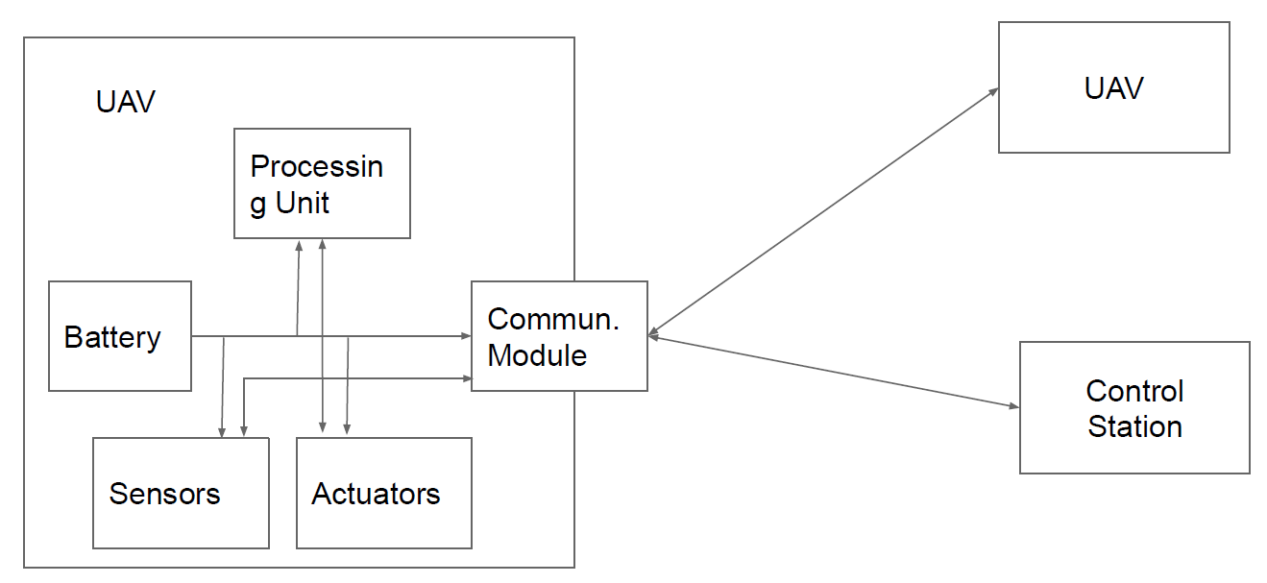

Drones are characterized by:

* multiple modules to acquire and process data;
* communication module as enabler.

UAVs employ control loops possibly with sensor feedback.

**APPLICATIONS**

* UAVs have been firstly proposed for military applications.
* Seventeen countries armed UAVs, and more than 100 countries use UAVs in military capacity.
* Civil applications are instead more recent.
* Thanks to their high adaptability, UAVs find applications in many different fields
  + Infrastructure
  + Transport
  + Media and Entertainment
  + Telecommunication
  + Agriculture
  + Search and Rescue

A drone ecosystem is composed by six unique targets:

1. Drone hardware: CPU, sensors, firmware.
2. Drone chassis and package: all non-electronic devices.
3. Ground control station: may be fixed or mobile.
4. First-Person View (FPV) channel: control channel via common communication protocols.
5. Pilot: person remotely controlling the drone.
6. Cloud services: some drone send telemetry of flight information to a cloud server if needed.

**ATTACKER MODEL**

Attacker aim: disrupt the legitimate task of flying a drone.

Attackers may be both civilian or military. Although military may have sophisticated equipments (e.g., cannons or predator birds), a civilian may still be able to impact on the drone. We consider a civilian that has access to equipments that can be purchased at a moderate cost (Software-Defined Radio, Computer, Commercial lasers, Butterfly net, Magnets).

An attacker may be of three types:

1. With direct physical access → access the drone or the GCS to modify the firmware or replace hardware parts.
2. Physically proximate → send, modify, and replay radio transmissions in order to hijack a drone.
3. Distant adversary → resides on the Internet and applies attacks against servers, drones, the GCS.

The impact of the attack can be measured according to the CIA triad

* Confidentiality: attack that reveals information about drone, pilot, telemetry or collected data.
* Integrity: attack that modifies the information delivered to or collected by the drone, GCS, cloud server or pilot.
* Availability: attack that causes the pilot to lose control of the drone due to forced landing, crash or hijacking.

**Drone hardware attacks**:

* Find vulnerabilities in the devices or software used by the drone
* Attack to the compass
  + Use a magnetic field to fool the compass and either hijack or prevent take off
* Attack on the stabilizing algorithm via camera sensor
  + Drones use a camera to collect images and stabilize the flight
  + To detect movements, UAVs use optical flow
  + Features can be modified by projecting laser beams on the ground, or projecting images on the ground
  + The drone will follow the projected features

**OPTICAL FLOW**

Optical flow is the pattern of apparent motion of objects, surfaces, and edges (basically, everything from which we can extract simple features) in a visual scene caused by the relative motion between an observer and the scene. Optical flow uses a sequence of successive images to allow for the estimation of motion. It tries to calculate the motion between two image frames which are taken at a predefined rate at every voxel position.

UAVs use a downward facing optical flow camera. They collect images and use the estimation to stabilize the flight. It can detect whether the drone is drifting by comparing successive

frames of the ground below. The sensor system will attempt to infer if the ground plane image has moved by a relative offset . If so, the system assume that the ground is stationary and the drone has drifted.

Optical flow first requires a feature detection algorithm to identify regions of the ground plane easy to track. These features are then provided as input to the optical flow algorithm. It then identifies the location of these features in successive images and uses the difference to compute the displacement. Classic configuration: use the Shi-Tomasi corner detection algorithm for feature detection and the Lucas-Kanade method to compute the optical flow.

**Shi-Tomasi Corner Detection**

Basic idea: use the derivative of the image to detect whether there is a sudden change of color in one direction. If only in direction, then an edge is detected. If in two directions, then a corner is detected. It is generally used because efficient, compared to more sophisticated but slower feature detectors (SURF, SIFT).

**Lucas-Kanade Optical Flow**

Assumes that the difference between two consecutive frames is small and approximately constant within some neighbourhood. This assumption is arranged for UAVs considering a combination of sufficiently high framerate and sufficiently low resolution.

For each corner pixel p returned by the feature detector, let us define a local window of n neighbourhood pixels *qi* for .

For each *i* let 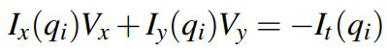 , where I denote the image matrix, pedix denotes partial derivative, and V the velocity or motion along a coordinate → estimate V via Least Squares.

Build system:



Matrix form *Av = b*

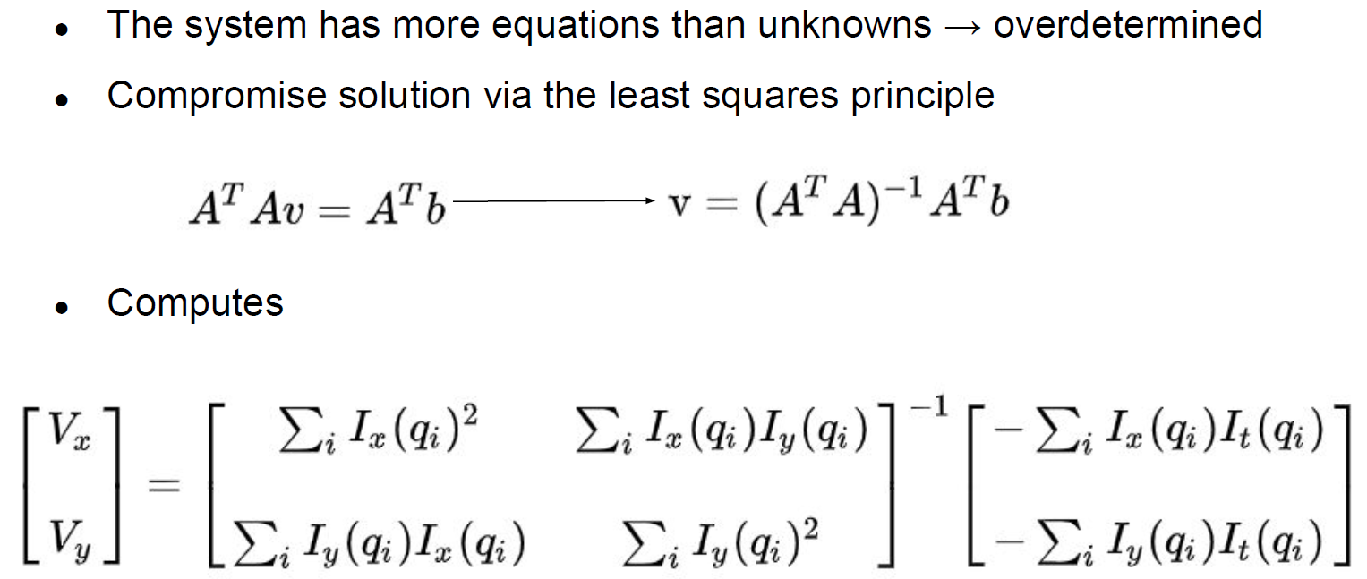

**ATTACKER REQUIREMENTS**

A successful attack to sensors needs three requirements.

1. Environment influence: the adversary can alter the physical phenomenon that the system measures (alter pixel values).
2. Plausible input: create an input to the sensor that will actually be used by the system as valid input.
3. Meaningful response: the attacker can induce a behavior on the UAV representing the control the attacker has over it.

1) **Environment Influence on Optical Flow**

* The adversary must be able to alter or obscure the ground plane to alter the pixel values reported by the optical flow camera.
* Onerous example: cover part of the area with feature-rich pattern.
* More concrete example: project features on the ground via laser/light beams.
* In the first case, the attacker can use a battery operated projector loading images e.g., from a USB stick.
* In the second case, use an array of laser elements to create features.

2) **Plausible Input to Optical Flow**

* The basic idea of optical flow is to instruct the UAV to compensate a drift by moving of the same amount in the opposite direction.
* The system assumes the image on the ground to be stationary, so it interprets feature motion along a vector as a movement in the opposite direction.
* By moving the ground feature, the attacker can control the movement of the drone.

3) **Meaningful Response to Optical Flow**

* The attacker’s goal is to project a sharp gradient onto the ground so that the feature detection algorithm will pick up the light as a corner.
* Since the Lucas-Kanade-based optical flow computes a final displacement based on the average displacement of each feature, the attacker needs to generate a large number of corners.
* In practice, the attacker can simply sweep their projected light across the ground plane.

Most UAVs are enabled with the **Return to Home** (RTH) functionality. The UAV records its location of departure, and in case of emergency it will automatically fly back to home. Emergency includes low battery or loss of the control signal for more than 3 seconds.

**CAPTURING DRONES**

Most UAVs rely on the Global Navigation Satellite System (GNSS) for positioning (e.g., Europe’s Galileo). However, this system has the main issue of not being authenticated. We can hence spoof the GNSS signal and control the location of the drone However, the drone is controlled by its pilot.

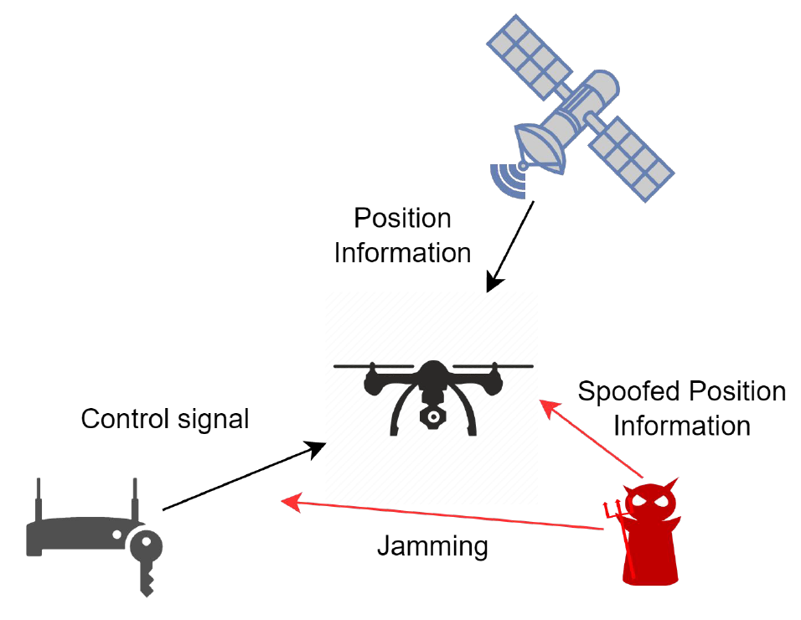

When jamming the signal for enough time, the drone enters the RTH mode and starts to fly back to the home location. With the help of the GPS module and the on-board compass, it can derive a trajectory based on its current location S and the home location H. The attacker aims at sending spoofed location information to capture the drone in the minimum time by bringing it to a controlled location D. To achieve the shortest capturing time, the attacker may want the

UAV to fly along the straight line SD. However, the drone has a pre-recorded H and will try to return there. If only one could spoof an arbitrary location to the UAV, then the UAV will change its direction immediately to any desired angle. For instance, given a location S’ such that S’H || SD, then the UAV will fly to D along SD. However, GPS accepts only physics-reasonable coordinates.

**Greedy Algorithm for UAV Capture**

Constraint: the maximum location change speed of GPS spoofing is Vs.

Idea: to minimize the capture time, the UAV trajectory shall be spoofed such that it points towards D as soon as possible.

* Loiter mode: the UAV tries to hold its position S by correcting any drift. We exploit this feature to have the drone gradually moving to D.
* An ideal spoofing trajectory is the one starting from the horizontal line a, where the arriving point is exactly above H.
* Besides spoofing, the UAV will always point towards the direction of H tanks to its compass.
* Whenever it believes it is on the left side of S1’, it moves closer to H horizontally.
* After passing S1, the UAV direction will turn left until it points precisely at D.
* Denoting S2’ as the turning point in the spoofed trajectory and its corresponding point in the actual trajectory as S2, S2’H || S2D.
* The UAV, convinced to be taking the spoofed trajectory S2’H, will fly along the straight line S2D until it reaches D.
* How to determine the spoofed trajectory S1’S2’ such that its actual trajectory becomes S1S2 and S2’H becomes parallel with S2D at the earliest time?
* Greedy algorithm to compute S2’.
* At the spoofed location S1’, the next spoofed point Sx’ is such that S1Sx’ is perpendicular to S1D.
* If SxD || Sx’H, done.
* Otherwise, repeat.



**GPS Failsafe**

GPS systems may occasionally drop the signal or suffer from glitches, i.e., provide significantly inaccurate position information. The GPS failsafe is mechanism to provide safety to the drone in case of GPS signal loss or glitches. In this case, the drone may either land or switch to a manual control. To protect against glitches, the drone has a short memory of GPS position and compares the new measurement with the old one (you can use Kalman filter also in this case).

We can classify consumer grade drones based on their behavior after failsafe mode

1. First type: switch from the failsafe mode to positioning mode which utilizes GPS.
2. Second type: resume autopilot just before loss-of-lock.
3. Third type: maintain GPS failsafe even though GPS is available and wait until a pilot gives a new command.

## **6.1 Safe Hijacking**

We want to develop an anti-drone system such that, as soon as we detect the drone, we do not simply interrupt the control channel and have the drone to hover over a sensitive area.

To carry out a mission that evades RC jamming by anti-drone solutions, terrorists will operate drones in autopilot mode based on GPS and will not rely on a remote controller. Therefore, spoofing GPS might be a solution to safely remove drones from an area they should not be into.

**Soft GPS Spoofing**

* The spoofing signal is aligned with the authentic GPS signal.
* The operation is not interrupted and the victim gradually locks to the spoofed GPS signals in three steps.

**Hard GPS Spoofing**

* Soft spoofing has some requirements to satisfy to avoid losing the lock.
* When one of the requirements is not satisfied, we call this signal as hard GPS spoofing.
* It initially acts like a jamming signal and the victim may lose its lock on the authentic signal.
* The spoofing signal is stronger, thus the victim will reconnect to the spoofed signal.

**Strategy A**

* It deals with type 1 drones.
* The drone is trying to maintain its original position.
* The attacker spoofs the target drone’s GPS position as if the drone is moving in a certain direction.
* The target drone generates speed in the opposite direction, so the drone moves in that direction in the real world.

**Strategy B**

* It deals with type 2 drones.
* Based on the drone’s characteristic that control their body according to their path-following algorithm (e.g., in RTH).
* If the GPS position is manipulated as the drone deviates from the path, then it will move in a different direction from the original direction to return to the track.
* The hijacker can determine the hijacking direction and calculate the corresponding fake location.

**Strategy C**

* It deals with type 3 drones.
* Since they need to wait for a pilot command, manipulation of GPS signal is not effective.
* Therefore, we want to hijack them without losing the connection with the GPS (soft GPS spoofing).
* However, it might be complicated to move the drone if it uses a combination of GPS and IMU sensors to determine its location.

**The 3DR Solo Case**

* 3DR Solo does not have a fallback mechanism when losing connection with the GPS.
* It is complicated to hijack, because it uses both GPS and IMU for
* localization
* It has a complicated path-following algorithm that uses Intermediate Target Position (ITP), necessitating moving the spoofed GPS location accordingly to safely control the behavior of the target drone
* Good case study for strategy C!

**PATH FOLLOWING ALGORITHM**

* The drone uses an Extended Kalman Filter algorithm to estimate various parameters, such as velocity, position, and magnetic filed by fusing the IMU’s output with GPS measurements.
* The EKF algorithm starts by predicting its position and velocity by using the IMU’s output only.
* IMUs have inherent errors → periodically compare its predictions with the GPS values and correct based on errors.

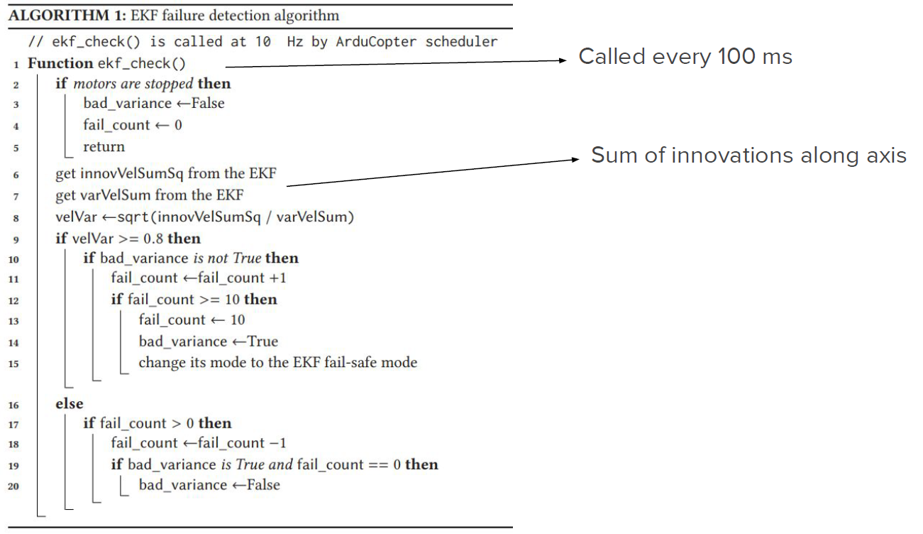

* During flight the drone might deviate from the track because of external influences such as wind.
* The path following algorithm is what prevent the drone from completely deviating from its mission.
* The ArduCopter path following algorithm is based on the ITP position.
* ArduCopter periodically advances the ITP along the track in small increments and causes the drone body to move to the ITP.



**SAFE HIJACKING STRATEGY**



* ITP remains unchanged if the drone is in Zone 1.
* Advances slightly forward along the track if in Zone 2 or 3.
* From the attacker’s point of view, the ITP can be estimated to be the physical location of the drone immediately prior to GPS spoofing.
* If the drone mistakenly determines that it has deviated from the track owing to GPS spoofing, then it will move in the direction away from the manipulated location to the ITP.
* The path following algorithm uses a *leash length*, i.e., a minimum distance from the current position to the main path.
* The attacker can exploit this distance to hijack the drone’s location.

**INITIAL FAKE LOCATION**

* The ITP is fixed or only slightly changed when the GPS location deviates from the main track by more than the leash length
* We can hence say that the physical location of the drone immediately before hijacking is an approximation of the updated ITP
* The attacker hence derive the possible coordinates of the initial fake location from the approximated ITP and the intended hijack direction
* We assume the attacker begins hijacking at the physical location pinit = (p1, p2, p3)
* Objective: move the drone to ptarget
* Hijacking direction = line between pinit and ptarget
* The drone will try to move to the ITP (approximately pinit) if its GPS location deviates from the track more than the leash length
* The direction from the initial fake location ainit = (a1, a2, a3) to the ITP should be the same as the hijacking direction

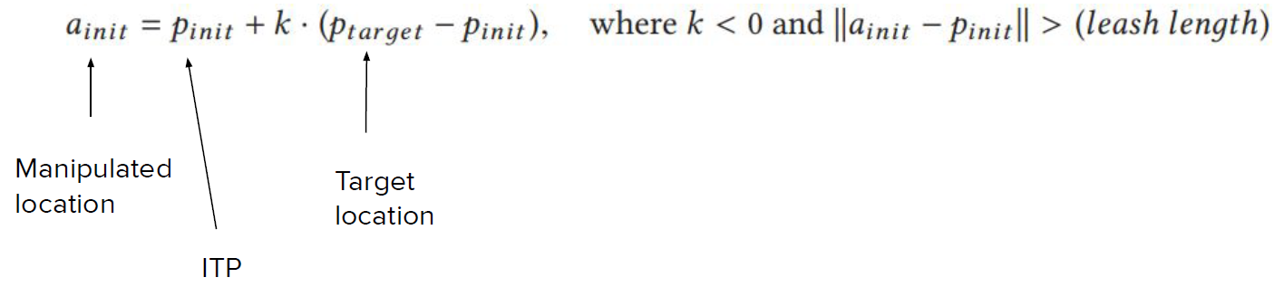

* The equation is the vector form of the parametric equation of a line
* Thus, ainit lies on the line that passes from pinot in the direction from target to pinot
* In addition, the distance between pinot and ainit should be higher than the leash length

**ADAPTIVE SPOOFING**

* The fail_count value will increase by one if the GPS location of the drone jumps to ainit because the GPS velocity and that measured by IMUs is not consistent.
* Therefore, the GPS velocity must be changed adaptively to be similar to the motion of the drone body to avoid triggering the failsafe mode.
* It makes the GPS location approach the drone’s original track to within the leash length, but we can prevent a change in the ITP by manipulating the GPS location to ainit again.
* The hijacker repeats the process until the drone reaches the safe target location
* The EKF failure count increases by one for each jump, but it will decrease to zero if the GPS velocity is consistent of that of the IMUs
* We define as t’ the current time, and as delta the GPS update period
* We update the current fake location as



**Flight Attitude Control**

* A drone needs a controller able to adjust the horizontal speed at a rotor level.
* Indeed multiple rotors are not always exactly the same and the center of mass cannot always be ensured.
* A flight attitude controller is hence implemented at a software level.
* Compute the proper control signal for multiple rotors based on the data from Inertial Measurement Units (IMU), including gyroscopes.

**ATTACKS TO UAV’S GYROSCOPE**

* An IMU is an electronic device using a combination of accelerometers, gyroscopes, and sometimes magnetometers to measure a body’s specific force.
* In a UAV, an IMU measures the orientation, rotation, and acceleration.
* Micro-Electro-Mechanical Systems (MEMS) gyroscopes are used to make flight control modules small.

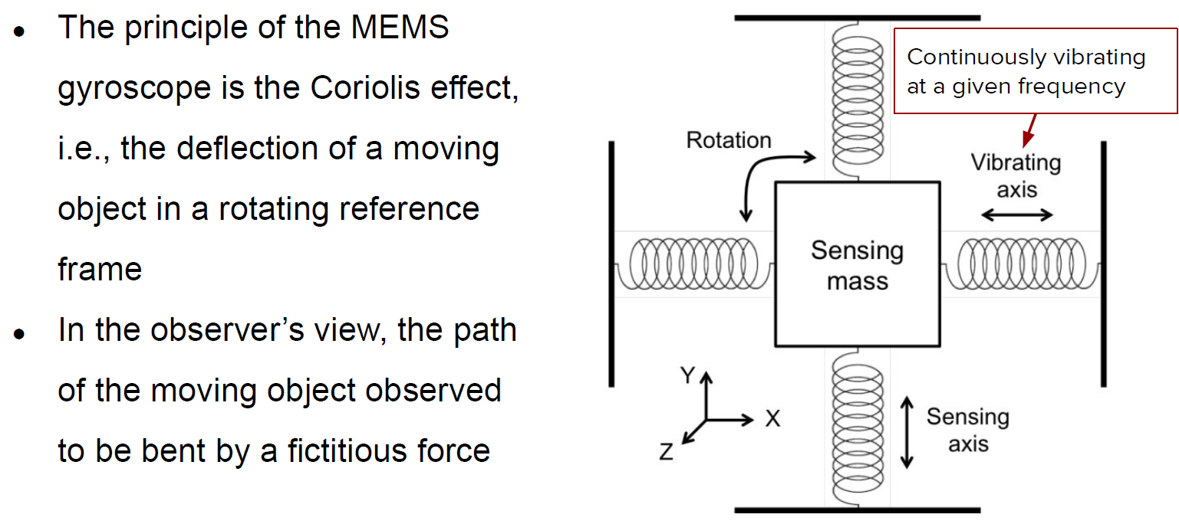

**Acoustic Noise Effect**

* MEMS gyroscopes are highly vulnerable to harsh acoustic noise.
* Such noise cause accuracy degradation, thus providing wrong results.
* A MEMS gyroscope has a resonant frequency related to the physical characteristics of its structure.
* Due to this resonance, if met, the gyroscope generates unexpected outputs that cause system malfunctioning.
* Usually, such frequencies should be ultrasound (above 20kHz).
* The sensitivity to noise can be exploited by an attacker.

**Setup**

* To effectively attack MEMS with audio, we need their resonant frequencies.
* A simple and reliable way, is exhaustive search → scan with single tone sound over a chosen frequency band.
* Use a consumer grade speaker connected to a laptop and placed 10 cm above the top of the target gyroscope.
* Generate single tone noises at frequencies from 100 Hz to 30 kHz at intervals of 100 Hz.

**Sound Source**

* A common noise measurement unit for the loudness of sound is the Sound Pressure Level (SPL).
* Another important property is the Total Harmonic Distortion plus Noise (THD+N), i.e., the ratio of the power of the harmonics and noise components to that of a fundamental component (in %).
* Sound source = tweeter.

**Noise Effect on MEMS**

* Gyroscopes fixed on a stable frame in an anechoic chamber.
* In the absence of noise, the variance of the measurements should be zero → difference in standard deviation as a criterion for the resonance of the gyroscope.



**Attack Design**

* The attacker, in order to design a good strategy, needs to understand what the drone is doing.
* Static analysis of the controller code to understand the reaction of sensor and actuators to noise.
* Usually drones can support different gyroscope implementations, however the main software routing is the same for all of them.

Software Analysis

* The main processor reads the raw data from the gyroscope’s registers through an I2C interface, along with the control data provided by the user.
* Raw data for each axis is stored in two 8-bit register → main inputs of the controller, which uses a PID logic to instruct rotors as follows.
  + P is proportional to the present output of the gyroscope, and if the present output is abnormally large the control from the transmitter can be ignored.
* Such raw data are them main inputs of the controller, which uses a PID logic to instruct rotors as follows.
  + I is proportional to the accumulated error between the output from the transmitter and the gyroscope, which can be ignored because usually its gain is very small.
  + D is proportional to the changes between the present output values and the gyroscope.
* Throughout the whole process the gyroscope data is not checked.

**Experiment**

* Attach a small bluetooth speaker above the target system gyroscope at a distance of 10 cm to serve as attacking source.
* The sound noise is turned on while the target drones were stably maintained in the air.
* To observe the status of the drone before, during, and after the attack, the speaker is turned off, on, and off again every 10 seconds.

# **7. Industrial Systems Security**

An **industrial control system** (ICS) is a broad class of automation systems used to provide control and monitoring functionality in manufacturing and industrial facilities. It is an aggregate of various system types:

* Process Control Systems (PCS)
* Distributed Control System (DCS)
* Supervisory Control and Data Acquisition (SCADA)
* Safety Instrumented Systems (SIS)

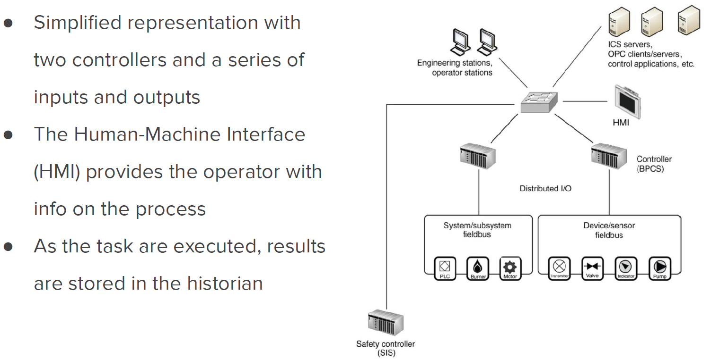

**Zones and Enclaves**

* These terms refer to closed groups of assets, or a function group of devices, services, and applications that make up a larger system.
* A zone describes a special network that is created to expose a subset of resources to a larger, untrusted network.
* This is often referred to as demilitarized zone.
* Used when enterprises want to place external-facing services, like web servers, email servers, B2B portals on the Internet while still securing their more trusted business networks.



**Common Recommendations**

* Identifying what systems need to be protected.
* Separating the systems logically into functional groups.
* Implementing a defense- in- depth strategy around each system or group.
* Controlling access into and between each group.
* Monitoring activities that occur within and between groups.
* Limiting the actions that can be executed within and between groups.

**Supervisory Control and Data Acquisition**

* Supervisory Control and Data Acquisition (SCADA) is a control system architecture comprising computers, networked data applications, and graphical user interfaces for high-level supervision of machines and processes.
* It also covers sensing and automation devices to interface with process plants or machineries.
* The operator can monitor the process and issues process commands via the SCADA computer system.
* Real-time control is performed by networked modules (controllers).
* SCADA can perform supervisory operations over a variety of other proprietary devices at different levels.
  + **Level 0:** field devices.
  + **Level 1:** industrialized input/output for direct control (PLCs/RTUs).
  + **Level 2:** supervisory computers aggregating information and provide the operator control screens (plant supervision → HMI).
  + **Level 3:** production control level that monitors production and target.
  + **Level 4:** production scheduling level.

Let’s see the components used in **industrial networks** and the role they play. Two main groups:

1. **Field components**, such as sensors, actuators, motor drives, gauges.
2. **Control system components**, such as programmable logic controllers, remote terminal units, intelligent electronic devices.

**PROGRAMMABLE LOGIC CONTROLLER**

* A Programmable Logic Controller (PLC) is a specialized industrial computer used to automate functions within manufacturing facilities.
* They are typically hardened, making them suitable for deployment in production environments.
* May be specialized for specific industrial uses with multiple specialized inputs and outputs.
* They do not use common operating systems, but rely on specific application programs that allow the PLC to function automatically generating output actions in response to specific inputs.



* They usually control real time processes, so they are designed for simple efficiency.
* Processing overhead and delay in the execution of the PLC functioning may impair a whole production process.
* The logic of PLCs is implemented via a standardized set of languages given by IEC-61131-3.
* Among them, we find Ladder Logics/Ladder Diagrams.
* The working principle of PLC can be understood as a cyclic scanning method, i.e., the scan cycle.
* The cycle goes on until the PLC is in run Mode.



* Part 3 of IET 61131 deals with basic software architecture and programming languages for PLCs.
* We have both graphical and textual programming languages:
  + graphical: Visual PL or block coding is a PL that lets users create programs by manipulating grèahical elements;
  + textual: classical languages you always used.

**LADDER LOGIC**

* Gets its name from the legacy methods of implementing discrete logic via electromechanical relays.
* Can be thought of as a set of connections between inputs (relay contacts) and outputs (relay coils).
* It defines a path consisting of logic steps that need to be fulfilled to allow for reaching the end.
* If one of the conditions is false, then the overall path is false and hence the output remains “de-energized”.
* The PLC applies this ladder logic by looking at inputs from discrete devices that are connected to the manufacturing equipment.
* It uses a thresholder to decide whether the input is true or false.
* Performs a desired output functions based on the state of these inputs.
* The outputs are connected to manufacturing equipment, such as actuators and motor drives.
* Can be thought of a rule-based language rather than a procedural
* language
* A “rung” in the ladder represents a rule.
* When executed in a PLC, these rules are executed sequentially by a software in a continuous loop or scan.
* By executing these loops at a high peace (many times per second), we achieve the effect of simultaneous and immediate execution.
* The language itself is a set of connections between logical checkers (contacts) and actuators (cols)
* If a path can be traced between the input and output through asserted contacts, the rung is true and the output coil storage bit is asserted (1)
* **Rung inputs:** checkers or contacts
  + -[ ]- : normally open contact, closed when its input is energized
  + -[\]- : normally closed contact
* **Rung outputs:** actuators (coils)
  + -( )- : normally inactive coil, energyzed when the rung is closed
  + -(\)- : normally active coil

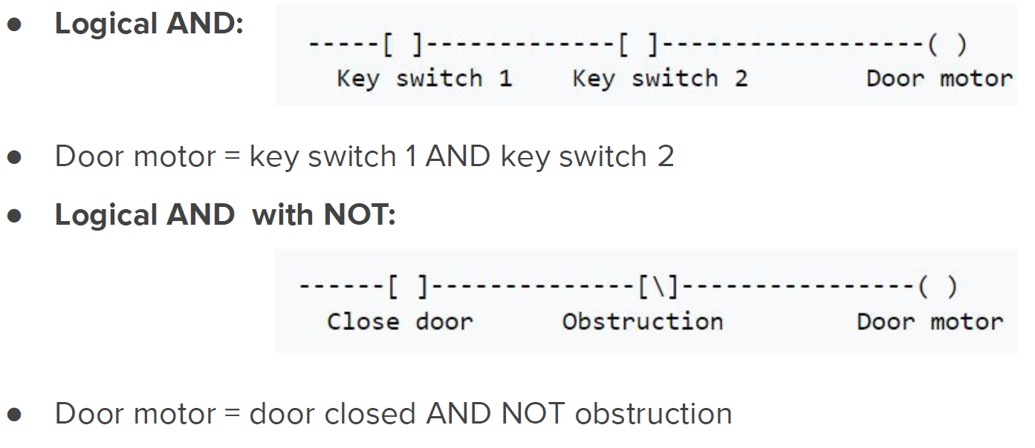

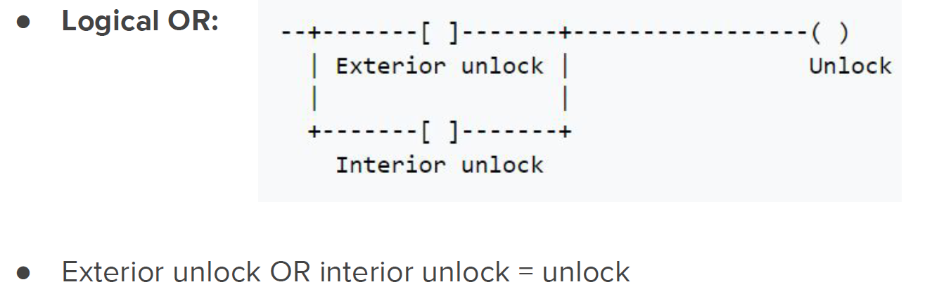

**INDUSTRIAL STOP/START**

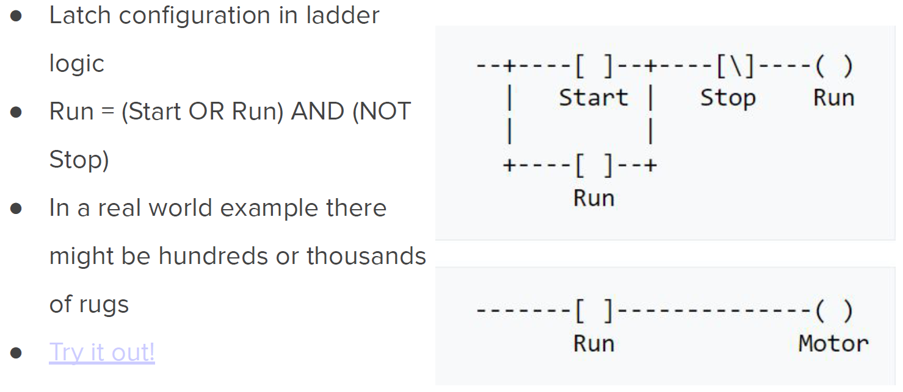

**REMOTE TERMINAL UNITS**

* A Remote Terminal Unit (RTU) monitors the field parameters and send this data back to a central monitoring station (e.g., an ICS server, a centrally located PLC, or HMI).
* RTUs typically reside in substations along a pipeline or some other remote location where there may not have easy access to electricity.
* They usually include communication capabilities, e.g., via modem, cellular data connections, radio or other wide area communication technology.
* Their communication bandwidth is generally limited.
* In order to maximize the information transmitted they use protocols supporting *report by exception* or other *publish-subscribe* mechanism.

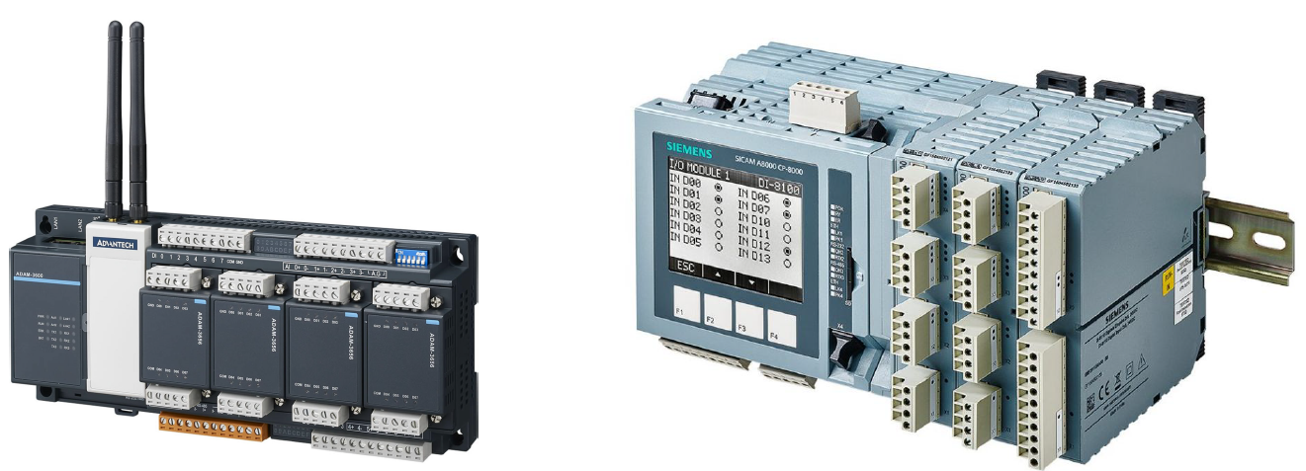

* An RTU is basically the interface between the physical world and the distributed control/SCADA system.
* They usually support the IEC 61131-3 programming standard for PLCs.
* It can monitor inputs of different types:
  + Digital: to acquire two state real-world information, usually accomplished by using an isolated voltage or current source to sense the position of a remote contact at the RTU side.
  + Analog: can monitor analog inputs of different types (current, voltage).
* Can also receive analog inputs from other on-field devices.
* It can produce outputs of different types:
  + Digital: may drive high current capacity relays to a digital output board to switch on or off on-field devices, may drive a sensitive logic input in an electronic PLC using a sensitive 5V input.
  + Analog: may be included in control devices that require varying quantities.
* They are usually capable of executing simple programs autonomously without involving the host computers of the distributed control system or SCADA.

**HUMAN-MACHINE INTERFACE**

* They provide the means for operators to interact with PLCs, RTUs, and IEDs.
* They replace manually activated switches, dials, and other electrical controls with graphical representations of the digital controls used to sense and influence the process.
* They allow the operator to start and stop cycles, adjust set points and perform other functions to adjust and interact with the control process.
* The HMI is at the top level near the human operator.



* The figure shows how it is integrated in the overall (up to now) system.
* The human interact with the HMI via a console, which however does not require authentication.
* They are hence deployed in physically strong security areas.
* The HMI uses software that may come in two forms.
* The first runs on operating systems such as Windows 11 and are capable of performing a variety of functions.
* The other form combines an industrial hardened computer, local touch panel, and typically utilize embedded operating systems.
* In this case, they are usually programmed with a separate computedand associated engineering software.
* The HMI shows the process instead of the logic behind it.
* Since they provide supervisory data as well as control, user access control should be part of the ICS.
* The HMI interacts with an ICS and hence with one or more controllers.

**Data Historian**

* It is a specialized software system that collects point values, alarm events, batch records, and other information from industrial devices and systems and stores them in a purpose-built database.
* Data that are historized and stored is referred to as *tags*, and car represent almost anything.
* Information used by both industrial operations and business management is often replicated across industrial and business networks and stored in data historians → security risk due to zones.

**Control Processes**

* Control process is a general terms used to define large automated process within an industrial operation.
* To manufacture a product or generate electricity, it might be necessary to use many control processes, each comprising one or more control loops.
* Examples: one process might be to inject an ingredient into a mixer utilizing a control loop that opens a valve in response to volume measurements within the mixer, temperature, and other conditions.



**SAFETY INSTRUMENTED SYSTEMS**

A risk management strategy should include different layers of protection to prevent a manufacturing environment to reach an unsafe operating condition. Safety Instrumented Systems (SIS) are deployed as part of a comprehensive risk management strategy. The basic process control systems is responsible for discrete and continuous control necessary for normal operations. In the event of an abnormal situation, the SIS takes over the control.

**Risks of SISs**

* There are risks originating within the SIS relating to cyber incidents.
* The prevention of the SIS from properly performing its control functions can allow the plant to transition into a dangerous state.
* Since the SIS operationally overrides the BPCS and its ability to control the plant, the SIS can also be used maliciously to cause unintentional equipment or plant shutdowns.
* To prevent this situations, we need to isolate the SIS to the greatest possible extent from other basic control assets.

**SIS Isolation**

* SIS programming is not usually allowed in operational mode.
* Highly authorized applications like SIS programming tools and SIS engineering workstations can be removed from ICS networks until they are required.
* SIS systems must be periodically tested to guarantee their functionality.
* This also includes cyber security assessments.

**INDUSTRIAL NETWORKING**

* An industrial network is any network that supports the interconnectivity of and communication between devices that make up or support an ICS.
* They may be local-area switched networks as common with Distributed Control Systems.
* They may be wide-area routed networks more typical of SCADA architectures.
* Most are Ethernet and IP-based and consist of both wired and wireless connectivity.
* Availability is prioritized over data integrity and confidentiality.
* Therefore, there is a great use of real-time protocols, UDP transport, and fault-tolerant networks interconnecting endpoints and servers.
* Bandwidth and latency are extremely important, because the applications and protocols in use support real-time operations that depend on deterministic communication often with precise timing requirements.
* Ubiquitous connectivity might not be something we want to achieve.
* The ICS requirements dictate the topology of the networks.
* High reliability and resiliency dictates the use of ring or mesh network topologies.
* Real-time operations and low latency require the minimization of switching and routing hops.

 

* Five sessions require 20 paths to be traversed.
* It is therefore necessary to minimize latency wherever possible to maintain real-time and deterministic communications.
* Therefore, we need to use switching unless traversing a functional boundary.
* We also need to use low level (Ethernet) firewalls and prefer a bridged mode, i.e., avoid relying on IP routing.
* As we go lower into the control environment, functionality becomes more specialized.
* Introduction of open and/or proprietary protocols in either their native form or adapted to work over Ethernet.
* Figure below: Fieldbus.



**Wireless Network**

* Wireless networks are bound by the same design principles as wired networks.
* However, they are more difficult to physically contain because they are bound by the range of the radio wave propagation from an access point rather than by physical cables and network interfaces.
* Any device that is equipped with an appropriate receiver and is within the range of a wireless access point can physically receive wireless signals.
* There is no sure way to prevent this physical (wireless) access.
* While it is possible to block transmissions by using jammers or signal-absorbing materials, these measures are costly and rarely implemented.
* Typically conduct thorough radio frequency surveys in order to not only place antennas in optimal locations, but also prevent unnecessary transmission of signals into untrusted and unrestricted areas.



**NETWORK SEGMENTATION**

* “Segmentation” pertains to the division of networks (network segmentation) or zones (zone segmentation) into smaller units.
* Important for many reasons, including network performance considerations and cyber security.
* Segmentation typically occurs at Layer 3 (the network layer) by a network device providing routing functions.
* The router blocks broadcasts, enabling a large flat Ethernet network to be broken up into discrete Ethernet segments.
* Segmentation provides an inherent degree of access control at each demarcation point
* Should be used to support zone segmentation whenever possible.
* Results in hierarchical networks, such that communication between two networks might require traversal of several networks.
* Just because a segmented network architecture supports communication flows between segments, it does not mean that this traffic should be allowed between segments.



**Physical vs Logical Segmentation**

* Physical segmentation refers to the use of two separate physical network devices (both passive and active components) to perform the isolation between networks.
* Logical segmentation refers to the use of logical functions within a single network device to achieve essentially the same result.
* Physical separation of systems (“air gap” separation) is still widely used in industrial networks when talking about the coexistence of basic process control and safety systems overseeing the same process.

**Creating zones from segment**

* Each industrial architecture is unique, not because of the selection of equipment, but how each system is deployed in a particular environment and how each system is integrated with other ancillary systems.
* A safety level applied to each system so that appropriate measures can be in place to ensure that each system performs as intended without unintentional consequences or interactions between systems.
* Assets at a particular site are grouped based on their relative security requirements or security level.

**Identifying zones**

* One of the biggest challenge is the creation of a set of base requirements to determine whether a certain asset should be in a certain zone.
* These goals can be broken down into categories
  + Based on communications and interactions
  + Physical access to assets
* Zones based on network connectivity are rather easy to understand.

**BASED ON CONTROL LOOPS**

…

**BASED ON PLANT**

…

There are many highly specialized protocols used for industrial automation and control. Since they are designed for efficiency, many of them usually forgo any feature or function that is not absolutely necessary. Many of them have been adapted to run on top of Ethernet and IP. Two categories:

1. Fieldbus: commonly found in process and control.
2. Backend: commonly deployed on or above supervisory networks, and are used to provide efficient system-to-system communication.

**MODBUS**

* Modbus is an application layer messaging protocol, meaning that it operates at **Layer 7** of the OSI model.
* It was designed in 1979 to enable process controllers to communicate with real-time computers.
* It remains one of the most popular protocols used in ICS architectures.
* It has been widely adopted as a de-facto standard, freely distributed, and well-supported by the Modbus Organization.
* It has been enhanced over the years into several distinct variants.
* It is based on a request/reply methodology allowing for efficient communications between interconnected assets.
* Extremely simple devices such as motors and sensors use Modbus to communicate with more complex computers.
* Therefore, message generation, transmission, and receipt all require very little processing overhead.
* It makes it a suitable protocol from PLCs and RTUs to communicate data to supervisory ICS.



* It is a request/response protocol using three distinct protocol data units
  + Modbus Request
  + Modbus Response
  + Modbus Exception Response
* Up to 32 devices can be connected on a single RS-485 serial link, requiring each device being assigned a unique address.
* A command is addressed to a specific modbus address.
* While other devices may receive the message, only the addressed device will respond.

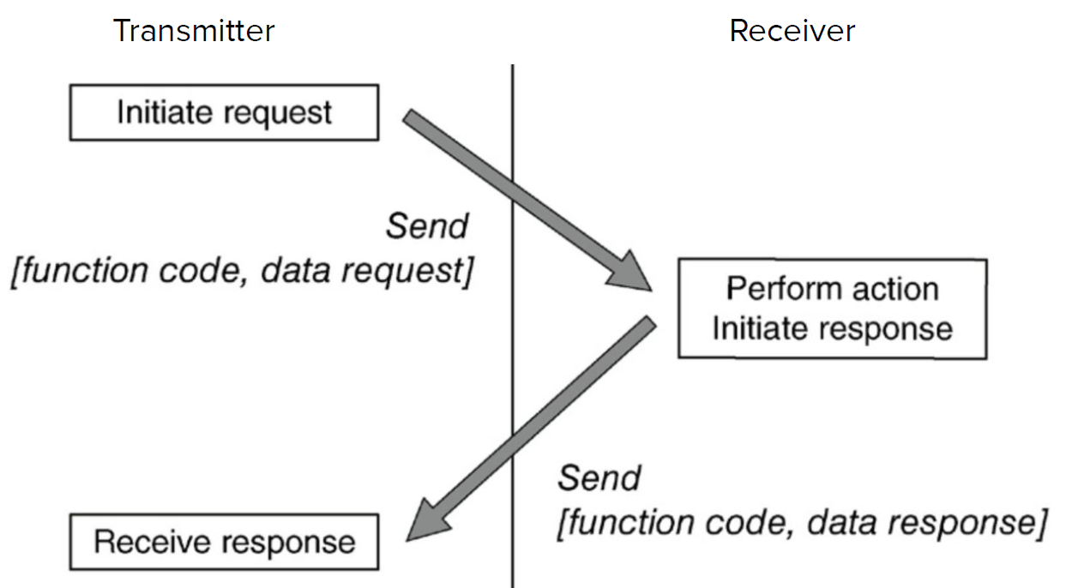

* A “transaction” begins with the transmission of an initial Function Code and a Data Request within a Request PDU.
* If there are no errors, the receiver will respond with a Function Code and Data Response within a Response PDU.
* If there are errors, the device will respond with an Exception Function Code and Exception Code within a Modbus Exception Response.



* Function Codes used in Modbus are divided into three categories and provide the device vendor with some flexibility in how they implement the protocol.
* Function codes in the range of 01–64, 73–99, and 111–127 are defined as “Public” and are validated by the Modbus-IDA community and are guaranteed unique.
* “User-Defined” function codes in the range 65–72 and 100–110 are provided to allow a particular vendor to implement functionality to suit their particular device and application.
* “User-Defined” function codes in the range 65–72 and 100–110 are provided to allow a particular vendor to implement functionality to suit their particular device and application.
* Function Codes and Data Requests can be used to perform a wide range of commands.
* E.g., Read the value of a single register, Write a value to a single register, Read a block of values from a group of registers, Obtain device diagnostic data.

**Where do we use MODBUS?** Modbus is typically deployed between PLCs (client) and HMIs (server). Modbus devices may also take the role of server in some communications, while being client in other communications.



**Security concerns**

* Modbus presents several security issues.
* It **lacks authentication**: sessions only require the use of a valid Modbus address, function code, and associated data.
* The data must contain the values of legitimate registers or coils contained in the slave device, or the message will be rejected.
* This requires additional information of the target in order to provide a valid message, which however can be obtained via e.g., traffic analysis.
* Possibility for man-in-the-middle and replay-like attacks.
* It **lacks encryption:** Commands and addresses are transmitted in clear text and can therefore be easily captured and spoofed or replayed due to the lack of encryption.
* Communications to/from a Modbus device can also disclose significant information pertaining to the configuration and use of the device.
* It **lacks message checksum:** a command can easily be spoofed by building up the Modbus/TCP ADU with the desired parameters, as the checksum is generated at the transmission layer, not the application layer.

**Security recommendations**

* Should only be used to communicate between sets of known devices.
* In this way it can be easily monitored by establishing clear network zones and by baselining acceptable behavior.
* This baseline behavior can then be used to establish access controlson the conduit into the zone via appliances that provide protocol inspecting and filtering capabilities.
* Suspicious messages: Modbus TCP packets that are of wrong size or length, function codes that force slave devices into a “listen only” mode, function codes that restart communications.

**Distributed Network Protocol**

* DNP3 was extended to work over IP via encapsulation in TCP or UDP packets in 1998, and is now applied in different industries.
* DNP3 is very reliable, while remaining efficient and well suited for real-time data transfer.
* It also utilizes several standardized data formats and supports time-stamped (and time-synchronized) data, making real-time transmissions more efficient and thus even more reliable
* A single DNP3 frame can include up to 17 CRCs.
* Variations of DNP3 support link-layer authentication.

**How DNP3 works**

* DNP3 is primarily used to send and receive messages between control system devices.
* It can also be used to send control functions, or even direct binary or analog data for direct interaction with devices, such as RTUs and IEDs.
* DNP3 provides a method to identify the remote device parameters and then use message buffers corresponding to event data classes 1 through 3 in order to identify incoming messages and compare them to known point data.
* In this way, the master station is only required to retrieve new information resulting from a point change or change event on the outstation.
* Initial communications are typically a class 0 request from the master station to an outstation, used to read all point values into the master station’s database.
* Subsequent communications will typically either be direct poll requests for a specific data class from the master station, or control or configuration requests from the master station to an outstation.

**Where we use DNP3**



**Security concerns**

* Much attention is given to the integrity of the data frame, there is no authentication or encryption inherent within DNP3.
* Some examples of realistic hacks against DNP3 include the use of MitM attacks to capture addresses, which can then be used to manipulate other system components.
* Examples: Turning off unsolicited reporting to suppress alarms, Spoofing unsolicited responses to the master station to falsify events, Performing a DoS attack through the injection of broadcasts.

**Secure DNP3**

* Secure DNP3 is a DNP3 variant that adds authentication to the response/request process
* Authentication is issued as a challenge by the receiving device.
* A challenge condition occurs upon session initiation, after a preset period of time, or upon a “critical” request, such as write.
* Authentication occurs using a unique session key that is hashed together with message data from the sender and from the challenger.
* In this way, it is very difficult to perform data manipulation or code injection, or to spoof or otherwise hijack the protocol.

# **8. Attacks and Detection in ICS**

…

## **8.1 Honeypot**

…

## **8.2 Stuxnet**

…

# **9. IoT Security and Privacy**

…

## **9.1 IoT Authentication**

…

## **9.2 Remote Attestation**

…